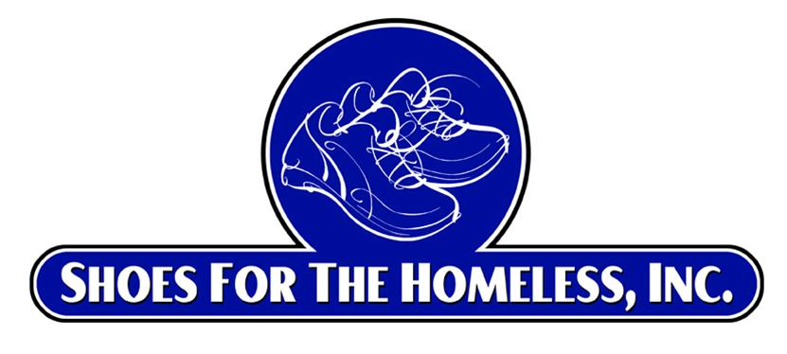
Shoes for the Homeless, Inc.
www.shoesforthehomeless.net
501 (c) (3) Non-Profit Corporation

Volunteer Youth Ambassador Program

Achievement Four: Participate in at least 3 monthly Volunteer Youth Ambassador Virtual (Zoom) meetings:

What do I hope to learn at the monthly VYA virtual meetings?
  - These meetings will be typically last 30+ minutes and be hosted by founder, Dr. Ira Diamond.
  - Our goal is to create a community of VYA candidates who appreciate helping the homeless and those in need.
  - We will often have guest speakers and hear from our VYA Coordinator, Miles Griffin.
  - This is also a time to answer questions and overcome any obstacles in achieving completion of the achievements.
    - Going over the required achievements for the VYA program and discussing any challenges that may have come up.
    - Having an opportunity to hear how other VYA candidates are doing.
    - Maintaining that attitude of gratitude and appreciation and the importance of helping the homeless and those in need.
    - Feel free to submit your questions prior to the meeting.

  - These meetings are only open only to Volunteer Youth Ambassador Candidates and their parent/guardian only.
  - Remember to add the dates you attended the virtual meetings to your completion form.
  - At these meetings we will review our mission and vision, the VYA required achievements and encourage our VYA Candidates to be successful.

