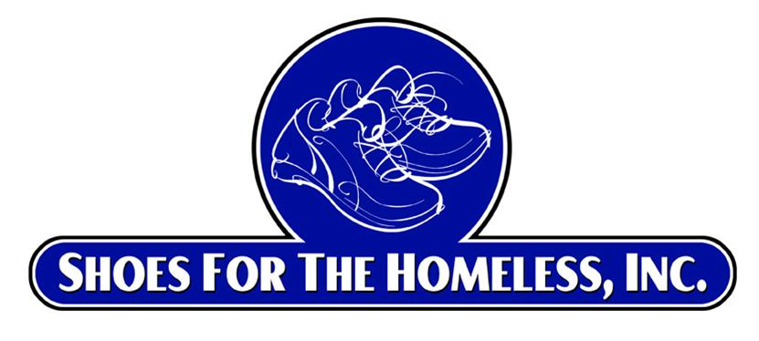

**Shoes for the Homeless, Inc.**

**Volunteer Youth Ambassador Program**

[**www.shoesforthehomeless.net**](http://www.shoesforthehomeless.net)

**501 (c) (3) Non-Profit Corporation**

**Program Overview**

Dear Volunteer Youth Ambassador Candidate,

We are here to help you be successful and to inspire you to have a life-long passion for helping those in need. Below you will find the program overview including required achievements. The Candidate has 6 months to complete all the achievements and to become an official Volunteer Youth Ambassador. If you need help, please reach out to [youthambassador@shoesforthehomeless.net](mailto:youthambassador@shoesforthehomeless.net). A VYA adult volunteer will be available to assist you. As you complete each achievement, please mark on the completion form the date it was completed and any other information requested.

* **Required Achievements to become a Volunteer Youth Ambassador:**
  1. Organize 1 or more shoe drives (see achievement number 1).
  2. Write a brief report on the statistics of homelessness in your community and identify a non-profit organization in your area who will accept the shoes from your shoe drive. (see achievement number 2).
  3. Make 2 or more presentations (see achievement number 3).
  4. Participate in at least 3 monthly Volunteer Youth Ambassador Virtual Zoom meetings (see achievement number 4).

**Community Service Hours:** Community service hours will be provided upon request (see below the number of hours of community service you will receive for each achievement).

1. Organizing a shoe drive (achievement 1) - 15 hours per shoe drive (minimum 100 pairs of shoes collected per shoe drive).
2. Writing a report (achievement 2) - 3 hours.
3. Make 2 or more presentations (achievement 3) - 1 hour per presentation.
4. Participate in at least 3 VYA Virtual (Zoom) meetings (achievement 4) - 1 hour per meeting.

## **Overview:**

* + The Volunteer Youth Ambassador program of Shoes for the Homeless, Inc. (SFTH) focuses on encouraging and empowering youth to make a difference in their community. Giving back to those in need, especially the homeless, makes a big positive impact on the individual you help, on your community as well as on you by making you feel good.
  + Providing a good pair of shoes to homeless men, women and kids significantly improves their quality of life.
  + As a Volunteer Youth Ambassador candidate, you will assume a leadership role and significantly help those in need.
* **Goals:** 
  + To help the homeless by providing much needed shoes. All the shoes collected will go to the homeless and those in need at no charge.
  + To engage others to raise awareness of the importance of shoes for someone who is homeless.
  + To learn about homelessness in your community and then make a positive impact by helping them to receive much needed shoes.
  + To inspire in our Volunteer Youth Ambassadors candidates an attitude of gratitude and appreciation for all we have and that helping others in need for a lifetime will not only help others but will enrich your life tremendously.
  + To earn community service hours.
* Upon completion of all achievements and once the **completion form** is signed off by the Candidate and SFTH, the Volunteer Youth Ambassador’s will receive:
  + Certificate of Completion from SFTH
  + Certificate of Appreciation from SFTH
  + Become part of our SFTH leadership Institute
* Being a Volunteer Youth Ambassador for SFTH may be an excellent resume builder for college and other opportunities. We hope that being a Volunteer Youth Ambassador this will inspire you to have an attitude and gratitude and want to give back to those in need for a lifetime.
* Monthly Zoom Meetings: At our monthly Zoom meetings, we will strengthen our VYA community, give updates, answer questions and hear speakers.

Sincerely,

cid:image001.jpg@01D71A74.0D5546E0

Ira Diamond, Founder

Shoes for the Homeless, Inc.