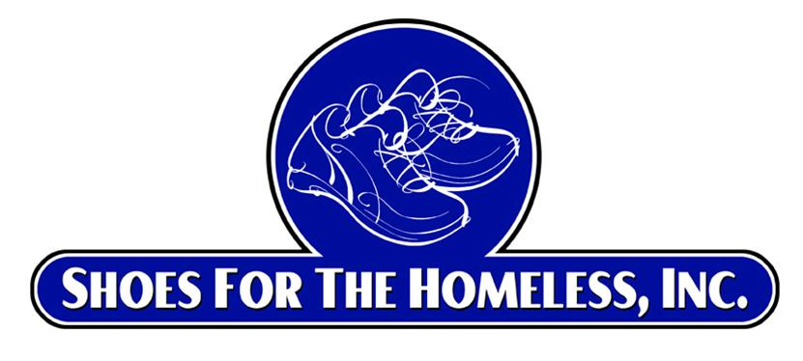
Shoes for the Homeless, Inc.
www.shoesforthehomeless.net
501 (c) (3) Non-Profit Corporation

COMMUNITY SERVICE FORM
Dear Sir or Madam,
This letter confirms that _________, as a Volunteer Youth Ambassador candidate for Shoes for the Homeless, Inc., completed the following community service hours.

Dates of Service Hours Worked Description of Work
_______ to ________ 15 hours
- Organizing a shoe drive in which men’s, women’s and kid’s shoes were collected.
- Raising awareness of the shoe drive including making a flyer and shoe collections box (s).
- Making sure the shoes were bagged and laces tied.
- Making sure that the recipient organization received the shoes to provide to the homeless, free of charge, much needed shoes.

Sincerely,
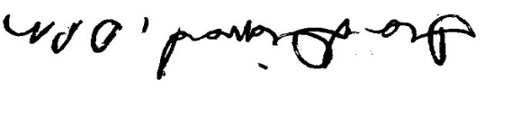

Ira Diamond, DPM
Founder and President

